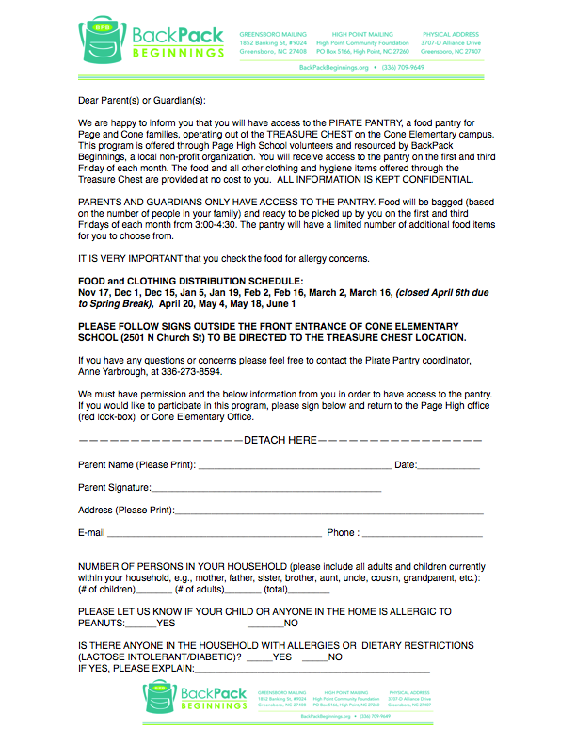

Dear Parent(s) and Guardian(s):

You are invited to access the **PIRATE PANTRY**, a food pantry for Page and Cone families, located in the **TREASURE CHEST** at Page High School. This food program is resourced through BackPack Beginnings, a local non-profit organization. Families who use the Pirate Pantry may also choose items from the Treasure Chest, which contains clothing, shoes, and hygiene items for children and adults. All items are provided at no cost and participation is CONFIDENTIAL. Your information will only be seen by the school social worker, Backpack Beginnings, and the Page Cares parent coordinator.

*To participate, you MUST complete and return this registration. Forms should be placed in the

RED LOCK BOX in the Page High School main office.You may also give it directly to your school social worker.

\**Remember to communicate clearly any allergy concerns and check your food each week for these issues.*

**Registration is for the school year or for a period of time dependent on your family needs. It is NOT for occasional, drop-in use.** Because of this, failure to pick up 3 times from the pantry will result in termination of access. Please alert the coordinator or school social worker if you will miss a pick-up date or want to stop participation.

Food will be boxed and may be picked up on *first and third Thursday of each month from 2:00-3:30*

at Page High School. We will contact you with exact location details once you are registered.

**2019: September 5 & 19, October 3 & 17, November 7 & 21, December 5** & **19**

**2020: January 9** & **23, February 6** & **20, March 5** & **19, April 2 &16, May 7** & **21**

**------------------------------------------------DETACH HERE---------------------------------------------------------**

***PLEASE PRINT CLEARLY!***

PARENT NAME (PRINT)___________________________________________________DATE______________

PARENT SIGNATURE__________________________________________________________

ADDRESS (PRINT) ____________________________________________________________

EMAIL (PRINT)________________________________________________________________

CELL PHONE (or number where you can be easily reached) ____________________________

STUDENTS NAMES/GRADES/SCHOOL (PRINT)_____________________________________

_____________________________________________________________________________

Referring Teacher/Coach/Staff_____________________________________________________

Total # in Household ________ How many adults? ________ Children?________

IS ANYONE IN THE HOUSEHOLD ALLERGIC TO PEANUTS?  *Please Check:*  NO____ YES____

DOES ANYONE IN THE HOUSEHOLD HAVE OTHER FOOD ALLERGIES

OR DIETARY RESTRICTIONS(LACTOSE INTOLERANT, DIABETIC)? *Please Check:* NO____ YES____

If yes, please describe ___________________________________________________________________

_____________________________________________________________________________________